

Mora Line Transmission Project
Don Carlos-Mora 345 kV and Mora-Arriba 115 kV Conductor change to 795 ACSS

Material Modification Assessment 4

Prepared By:
Utility System Efficiencies, Inc. (USE)

September 13, 2021
Version 1.2

Prepared by
Ben Stephenson, P.E. | Utility System Efficiencies, Inc.

Foreword
Ameren, the owner of the Mora Line Transmission Project, has initiated a Material Modification Assessment (MMA) to evaluate the impact of changing the Don Carlos-Mora 345 kV line from bundled 795 ACSR to bundled 795 ACSS and the Mora-Arriba 115 kV conductor from 1272 ACSR to 795 ACSS. The change will not physically impact the line connections at Springer or Arriba substations. This assessment assumes MMA #1 (conversion of three-terminal Mora-Springer-Arriba 115 kV line to Mora 115 kV open-ring bus) and MMA #2 (conversion of Don Carlos-Mora 230 kV line to 345 kV) are in place and focuses on the reliability impact of such change. MMA #3 is not being pursued by Ameren at this time.

This MMA #4 report is prepared for Ameren by Utility System Efficiencies, Inc. (USE). Any correspondence concerning this document, including technical questions, should be referred to:

Chris Koty
Transmission Planning Engineer
Ameren
ckoty@ameren.com
Phone: (314) 554-3187

and

Ben Stephenson
Principal Power Systems Engineer
Utility System Efficiencies, Inc
BenStephenson@useconsulting.com
Phone: (916) 749-8550

Mora Line Transmission Project Material Modification Assessment 4
Table of Contents

1 Executive Summary 3
2 Study Description and Assumptions 5
3 Results and Findings 6
3.1 Reactive Power Analysis 6
3.2 Power Flow Analysis 6
3.3 Transient Stability Analysis 7
3.4 Fault Duty Analysis 7

LIST OF APPENDICES
Appendix A – Power Flow Plots
Appendix B – Transient Stability Plots

LIST OF TABLES AND FIGURES

Table 1. Fault Duty Results (kA) After 5 Cycles 7

Figure 1. MLTP MMA #4 Design 4
Figure 2. Mora Line Transmission Project Change #4 Detail (change to 795 ACSS) 5

Executive Summary
Lucky Corridor LLC, finalized the Don Carlos Wind Farm System Impact Study (SIS) on March 27, 2019 under provisions of the pro forma Open Access Transmission Tariff (OATT) Section 32 to be filed by Lucky Corridor. The study was coordinated with PNM and Tri-State as affected systems.

The Don Carlos Wind Farm (DCWF) project has requested to interconnect 181.44 MW gross to the Mora Line Transmission Project (MLTP) at Don Carlos switching station using 72 General Electric (GE) 2.5-127 turbines. Ameren has previously initiated two Material Modification Assessments (MMA) described below:
- MLTP MMA #1: Change the three terminal Mora-Springer-Arriba 115 kV line segment of into two distinct 115 kV lines by adding a second 115 kV circuit breaker to provide operating and maintenance flexibility.
- MLTP MMA #2: Change the Don Carlos-Mora 230 kV line to 345 kV.

A third planned MMA is no longer being pursued by Ameren but the MMA numbering sequence is being maintained. Thus this assessment #4 evaluates the impact of changing the Don Carlos-Mora 345 kV line segment conductor from bundled 795 ACSR to bundled 795 ACSS and the Mora-Arriba 115 kV line segment conductor from 1272 ACSR to 795 ACSS. The change will not physically impact the line connection to Tri-State at Springer or to PNM at Arriba. This assessment focuses on the reliability impact of such change.

The base cases used in the SIS, MMA #1, and MMA #2 studies are re-used in this study with the updated power flow models. The original SIS cases are used as the baseline to compare the performance of the proposed change.

Figure 1 on the following page illustrates the proposed new MLTP connection at the Mora substation with MMA #1, MMA #2, and MMA #4 applied. An “open ring” arrangement at the Mora 115 kV will inherently protect against the transient stability concerns that occur when the Mora-Springer 115 kV line trips following a three-phase line fault with the DCWF online above 100 MW. The open ring ensures that a fault to the Mora-Springer 115 kV line open-ends the Mora-Arriba 115 kV line and the Mora 345/115 kV transformer, tripping the DCWF and inherently eliminating the transient stability concern without the need for a Remedial Action Scheme (RAS) to mitigate.

Overview
The technical analysis conducted as part of this MMA study includes power flow, transient stability, and short circuit analysis. Power factor of the DCWF is not impacted by this slight impedance change to the 115 kV conductor.

Figure 1. MLTP MMA #4 Design
Mora
Don Carlos Wind Farm
Springer
Arriba
345 kV
115 kV
Mora
Don Carlos Wind Farm
Springer
Arriba
230 kV
115 kV
SIS Design
New Design
MMA1
(New CB)
MMA2+MMA4
(795 ACSS Bundled 345 kV Line, 400 MVA 345/115 kV Tran)
MMA4
(795 ACSS)
Results
This study has the following results:

- Increase the planned 345 kV shunt reactor from 40 MVAr to 43 MVAr.
- Negligible power flow impact
- No transient stability impact
- No material fault duty impact

This design change is deemed to have no material impact upon the SIS results and is acceptable.

Study Description and Assumptions
This study evaluates the impact of the MLTP MMA #4 change using the Heavy Summer, Heavy Winter, and Light Summer post-project cases used in the SIS, MMA #1, and MMA #2 studies. The new detailed MLTP MMA #4 model is shown in Figure 2 below.

Figure 2. Mora Line Transmission Project Change #4 Detail (change to 795 ACSS)
MMA2
Increase from 20 MVAr to 43 MVAr
Mora
Sub
Don Carlos Switching Station
Springer
Arriba
345 kV
115 kV
MMA1
(New CB)
MMA2+MMA4
795 ACSS Bundled (2x) 345 kV Line
400 MVA 345/115 kV Tran
400 MVA
Z=2 %
Z Base =100 MVA
X/R = 40
R = 0.002280
X = 0.019783
B = 0.338242
MVA = 1692
38.9 miles
400 MVA
Z=8.3 %
Z Base =112.8 MVA
X/R = 30
Don Carlos Wind Farm (180 MW)
MMA4
795 ACSS
R = 0.061907
X = 0.406985
B = 0.050737
MVA = 282
69.7 miles
Power flow, transient stability, and short circuit analysis is performed to determine if there is a material impact.

Results and Findings

Reactive Power Analysis
Flow is observed to be 4 MVAr through the Mora 345/115 kV transformer when the DCWF generation is offline and the 40 MVAr shunt reactor is inserted. Tri-state will only allow up to 2 MVAr of flow when the DCWF generation is offline. Therefore, the planned shunt reactor will need to increase from 40 MVAr to 43 MVAr. Doing so will reduce the reactive power flow from 4 MVAr to 0 MVAr.
The following summarizes the voltages and reactive power flow under each scenario case with the Don Carlos shunt reactor increased to 43 MVAr:
In the heavy summer case with Gladstone PST at 180 MW, flow is observed to be 4 MVAr through the Mora 345/115 kV transformer when the DCWF generation is offline and the 43 MVAr shunt reactor is inserted. The voltage at Don Carlos 345 kV is 1.042 pu and at Mora 345 kV is 1.045 pu.
In the heavy winter case with Gladstone PST at 115 MW, flow is observed to be 0 MVAr through the Mora 345/115 kV transformer when the DCWF generation is offline and the 43 MVAr shunt reactor is inserted. The voltage at Don Carlos 345 kV is 1.040 pu and at Mora 345 kV is 1.044 pu.
In the heavy winter case with Gladstone PST at 180 MW, flow is observed to be 0 MVAr through the Mora 345/115 kV transformer when the DCWF generation is offline and the 43 MVAr shunt reactor is inserted. The voltage at Don Carlos 345 kV is 1.029 pu and at Mora 345 kV is 1.033 pu.
In the light spring case with Gladstone PST at 190 MW, flow is observed to be 0 MVAr through the Mora 345/115 kV transformer when the DCWF generation is offline and the 30 MVAr shunt reactor is inserted. The voltage at Don Carlos 345 kV is 1.035 pu and at Mora 345 kV is 1.039 pu.

Power Flow Analysis
There is no material impact to the power flow contingency results with the conductor change 795 ACSS. For information purposes the change to the pre-contingency basecase flows on the Mora-Arriba 115 kV as compared to the SIS are noted as follows:
- Under Heavy Summer conditions with the Gladstone PST at 180 MW (SIS Case 3), the flow on the Mora (Tap)-Arriba 115 kV line at Arriba reduced from 49.2 MW to 47.8 MW.
- Under Heavy Winter conditions with the Gladstone PST at 115 MW (SIS Case 6), the flow on the Mora (Tap)-Arriba 115 kV line at Arriba reduced from 51.9 MW to 50.5 MW.
- Under Heavy Winter conditions with the Gladstone PST at 190 MW (SIS Case 8), the flow on the Mora (Tap)-Arriba 115 kV line at Arriba reduced from 61.9 MW to 60.4 MW.
- Under Light Spring conditions with the Gladstone PST at 190 MW (SIS Case 11), the flow on the Mora (Tap)-Arriba 115 kV line at Arriba reduced from 35.4 MW to 34.4 MW.

Transient Stability Analysis
There is no material difference in the transient stability performance with conductor change to 795 ACSS.

Fault Duty Analysis
This study evaluated the fault current at select locations from a Tri-State system perspective similar to what was performed in the SIS. The wind turbine will contribute up to 3.0 per unit fault current for up to 5 cycles, after which it returns to normal contribution of 1.0 per unit. The fault current is re-calculated under the current limiting conditions. The fastest breaker clearing time on the Tri-State 115 kV system is 6 cycles making the current limiting results the most applicable.
Table 1. Fault Duty Results (kA) After 5 Cycles
 | Pre-Project |  | Post-Project SIS |  |  |  |  |  | Post-Project, MMA4
Outage | 3Φ | 1Φ | 3Φ | X/R | Inc | 1Φ | X/R | Inc | 3Φ | X/R | Inc | 1Φ | X/R | Inc
Clapham 115kV | 1.750 | 1.460 | 1.747 | 9.63 | -0.00 | 1.423 | 6.90 | -0.04 | 1.768 | 9.65 | 0.021 | 1.442 | 6.92 | 0.019
Gladstone 115kV | 3.336 | 4.410 | 3.600 | 11.92 | 0.26 | 4.698 | 13.09 | 0.29 | 3.637 | 11.99 | 0.037 | 4.753 | 13.19 | 0.055
Hess 115kV | 1.425 | 1.020 | 1.430 | 36.21 | 0.01 | 1.002 | 6.63 | -0.02 | 1.448 | 36.27 | 0.018 | 1.015 | 6.70 | 0.013
Springer 115kV | 3.586 | 3.290 | 4.592 | 10.44 | 1.01 | 4.841 | 9.58 | 1.55 | 4.590 | 10.74 | -0.002 | 5.676 | 13.74 | 0.835

The station with the largest increase in fault current is the Springer 115 kV bus with an increase in 2.39 kA after 5 cycles which is 0.835 kA higher than what was determined in the System Impact Study. While the fault currents have increased, no breakers are likely overstressed in the region to cause the increase to be material.

Appendix A

Power Flow Plots

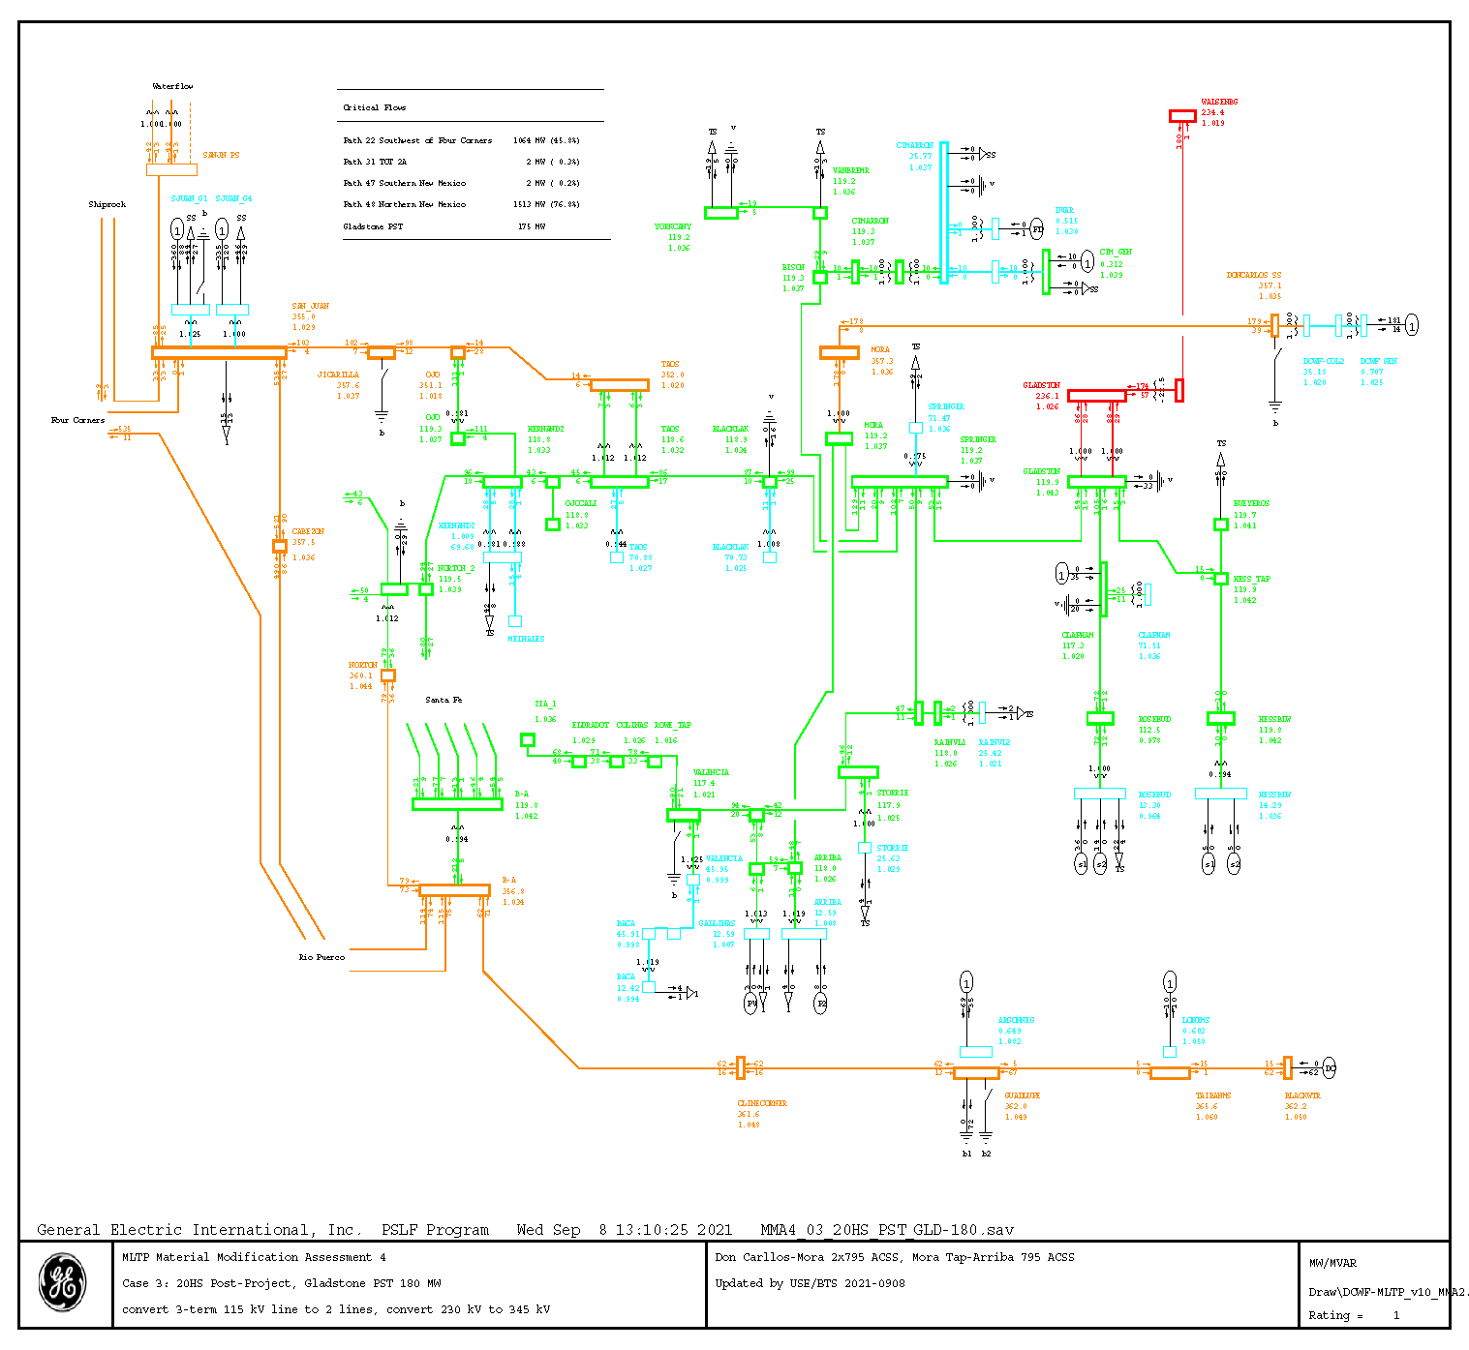
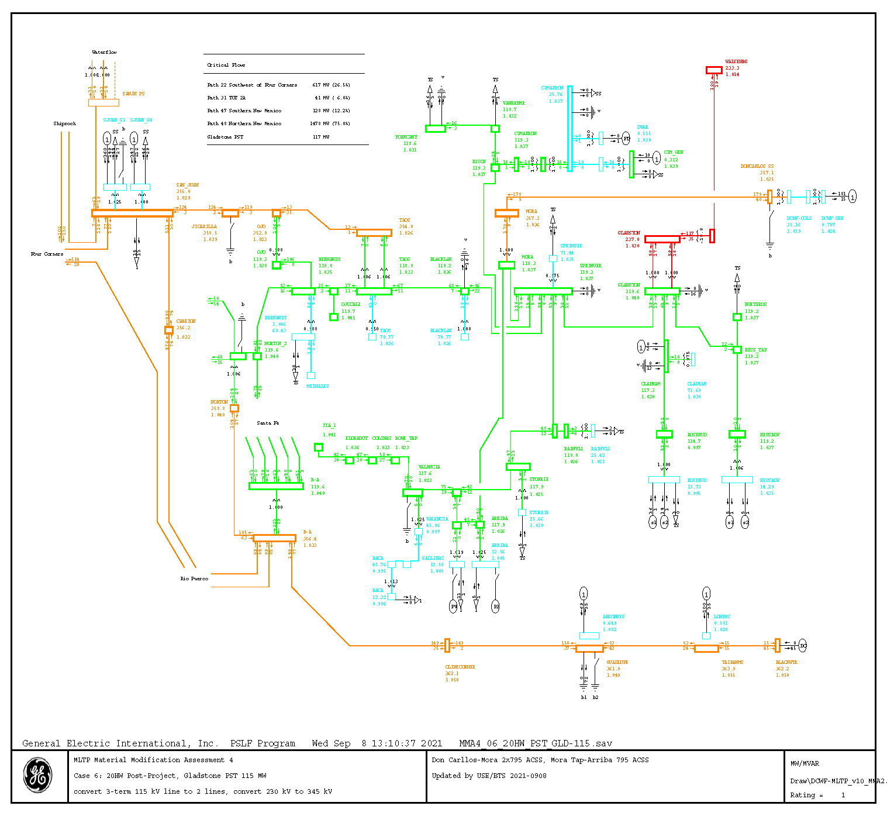
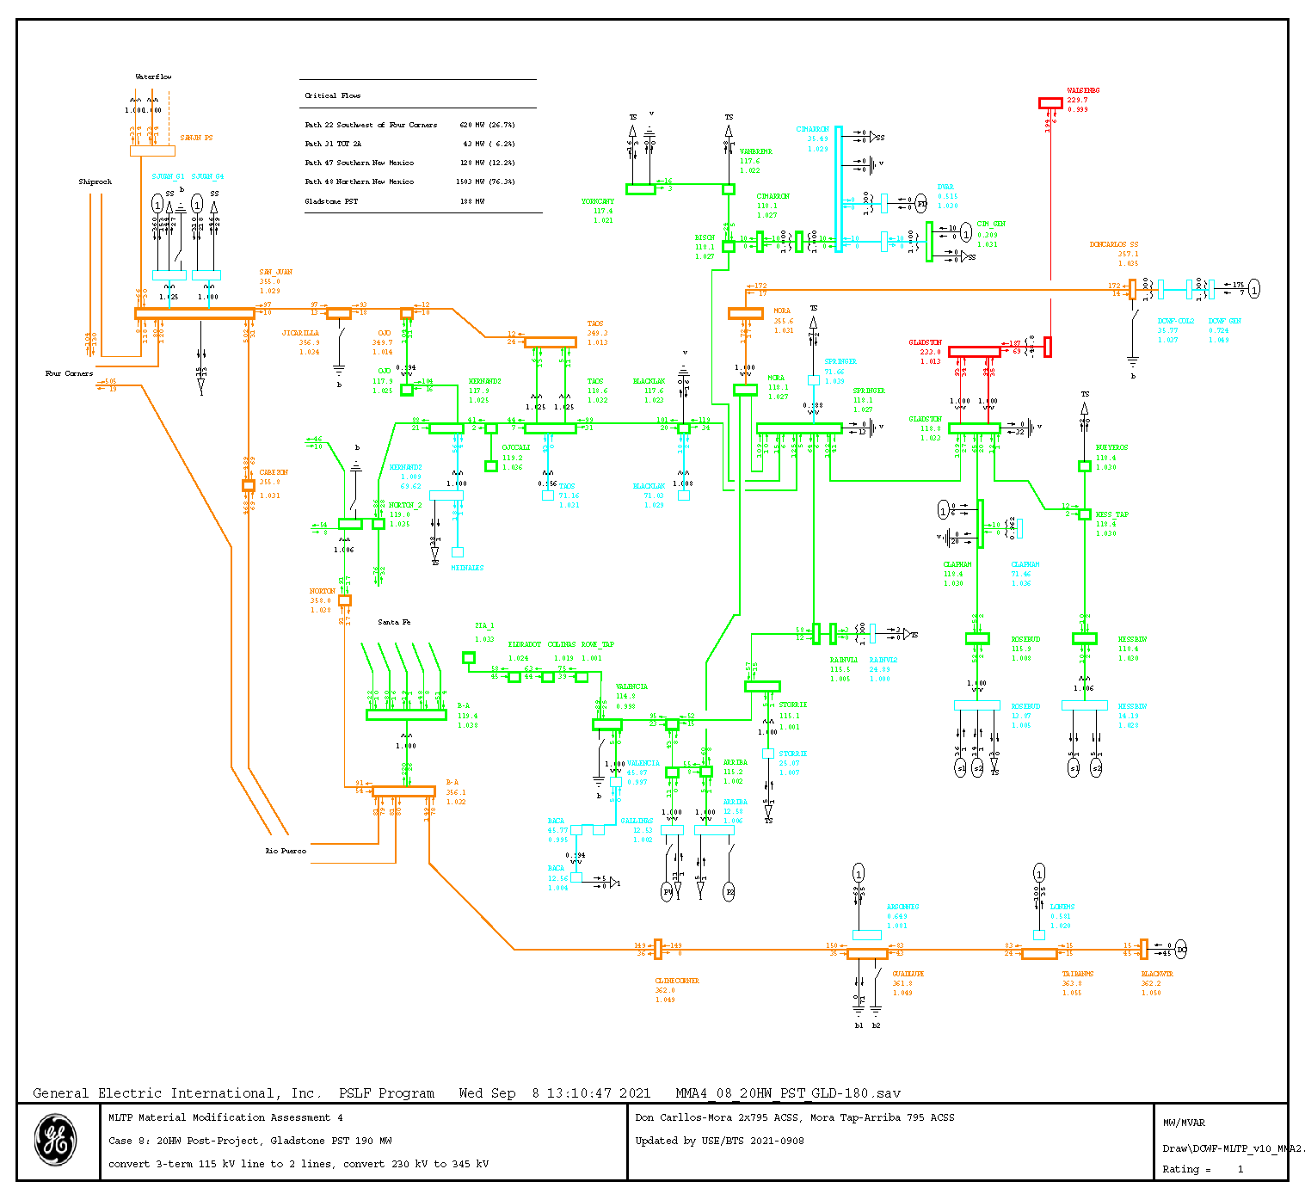
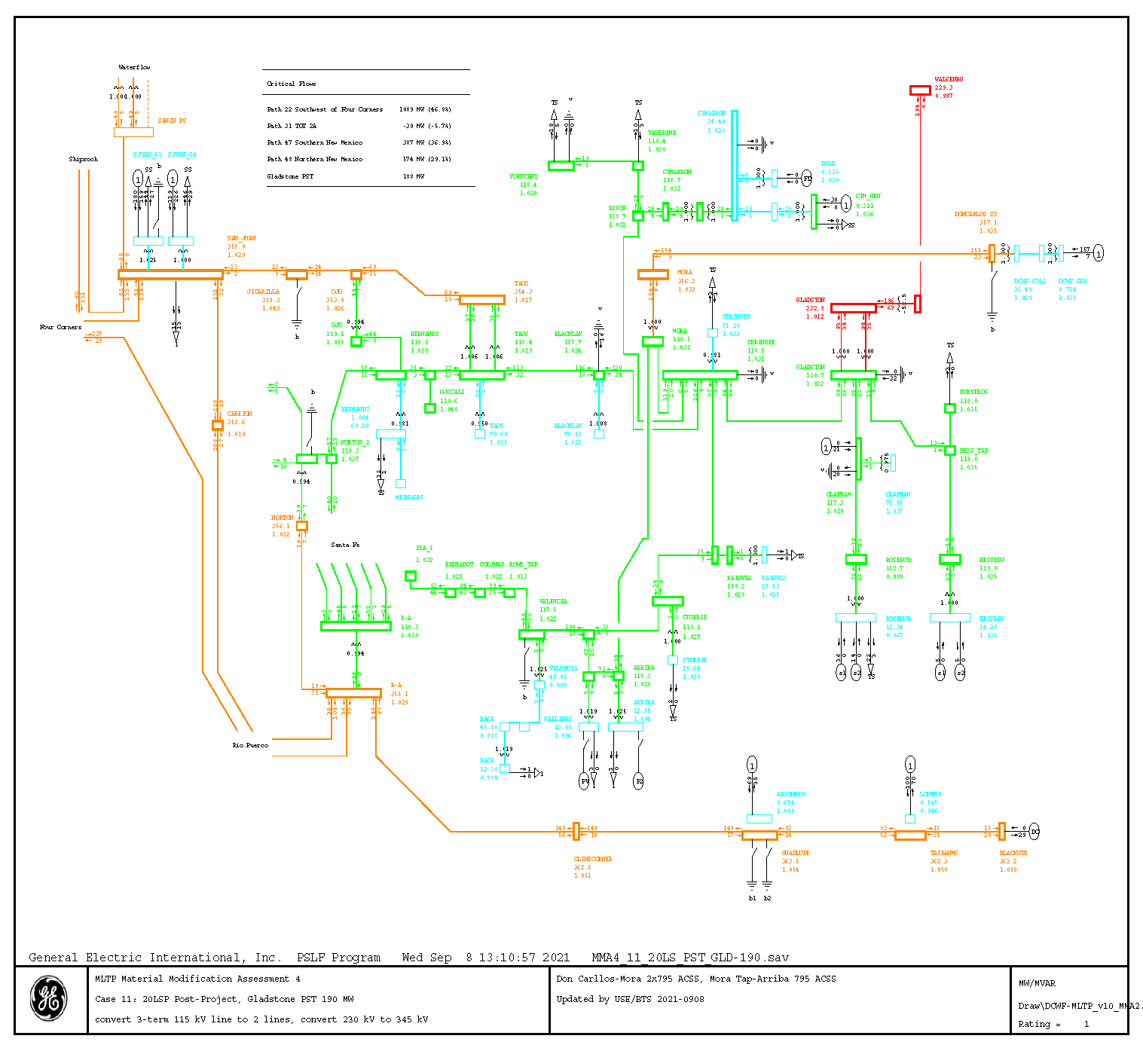

Appendix B

Transient Stability Plots

Available upon request due to large number of plots

Don Carlos Wind Farm System Impact Study Report posted on the Lucky Corridor OASIS at: https://luckycorridor.com/oasis/

